MONA FRANCIS
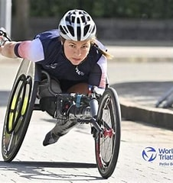
NAME: Mona Francis
DATE OF BIRTH: 26th December 1990 (33 years old)
PLACE OF BIRTH: France
RECORD
2023: European championship, bronze medal PTWC
2022: European championship, gold medal
2021: competed in the paralympic games, 6th PTWC

Questions:
- What motivated you to practice a sport?

I wanted to meet other disabled people like me so I subscribed into a swimming club for the disabled. I started practicing at a high level later.

- At what age did you start?

I started triathlon when I was 26 years old

- What is the most complicated thing in this sport?

The athletic wheelchair is very complex. First, you must find the right position to be able to do efficient and short gestures. Then, you must learn how to push the chair. It is not easy at all and it is not frequent enough to find help when you start.

- What does a high-level sportsperson eat? Do you eat the same way while competing?

I am very careful to what I eat because I want to maintain my nutritional intake for the day/the week. As you never stop training you must be able to keep up. When I am competing I eat lightly and I don’t try anything new to avoid digestive issues.

- What do you feel during training/during a competition?

It depends on the competition, the atmosphere, the public, on what is at stake. However, most of the time I am in my own bubble, I don’t hear what is going on around me. Sometimes I can feel burning in the muscles and in the chest too because of the intense and long training you have to do.

- Why should everyone practice a sport?

Because it is healthy and also because you can extend your relationships. It is an occasion to make new acquaintances and to share a common passion.

