Pierre-Marie HILAIRE

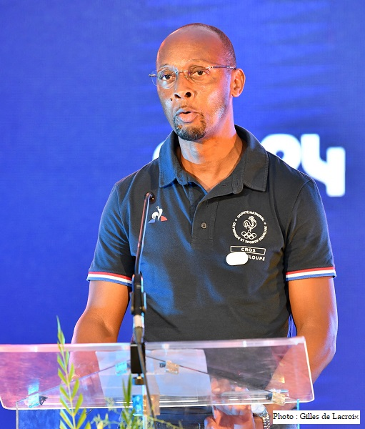
NAME : Pierre-Marie HILAIRE
DATE OF BIRTH: November 19th 1965
PLACE OF BIRTH: Deshaies,Guadeloupe (France)
RECORD :
2000 : competed in the Olympic games in Sydney 4X400M
1997 : World athletics championship 4x400m, bronze medal
1995 : European championship 400m indoor, silver medal

Questions

- What motivated you to practice a sport?

It came from the fact that I liked challenges. I always wanted to be among the first ones.

- At what age did you start?

I started when I was 19 years old

- What is the most complicated thing in this sport?

The most complicated thing is that you must train a lot. You must also do your best to stay at a high level as long as possible.

- What does a high-level sportsperson eat? Do you eat the same way while competing?

It depends on the morphology of the athlete. We are more careful when we have competitions.

- What do you feel during training/during a competition?

During training, you think of the sacrifices you made to achieve this point and you tell yourself that effort must pay off.

- Why should everyone practice a sport?

Everyone should practice a sport because it is important for your personal balance and your health

